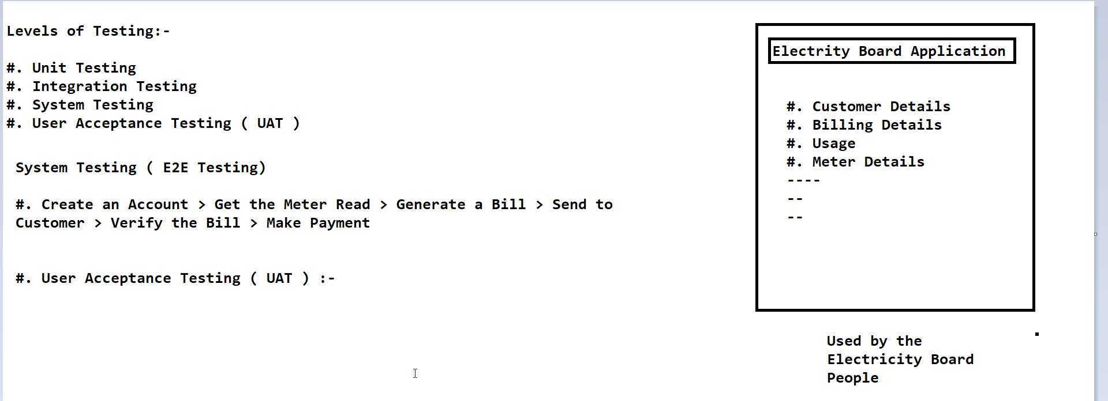

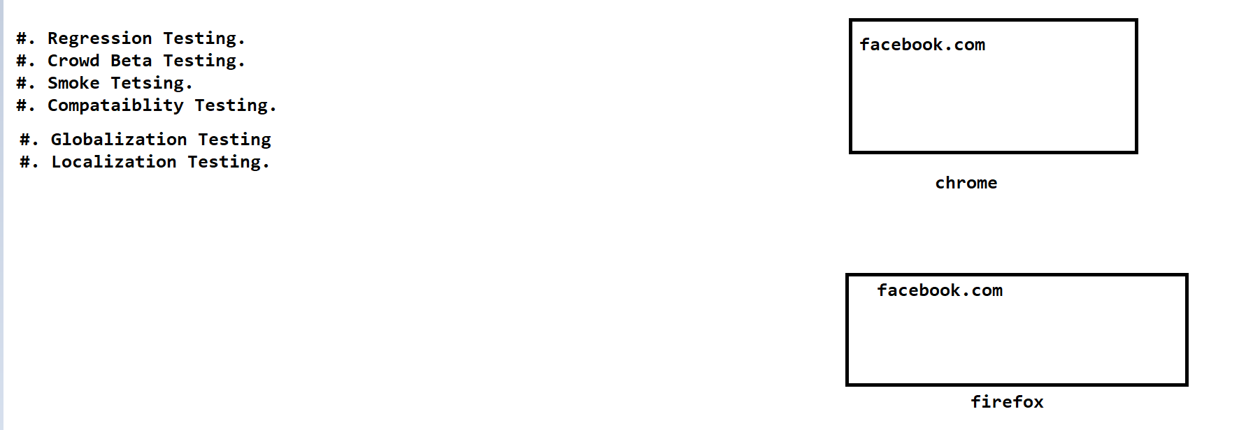

**Software Testing Project:-**

**#. Project Introduction**

**#. Understand and Explore the Functionality. ( FDD,TDD etc)**

**#. Test Plan**

**#. Write Test Scenarios**

**#. Write Test Cases and do the Review.**

**#. Test Environment SetUp and Build Deployemnt.**

**#. Test Execution**

**#. Bug Reporting and Tracking**

**#. Sanity Testing,ReTesting, Regression Testing etc.**

**#. Test Sign Off.**

**Project and Product**

**Product:-**

**#. eCommerce Application**

**Modules:-**

**1. Registration**

**2. Login**

**3. Search for Product**

**4. Add to Cart**

**5. Payment**

**6. Return the Product**

**etc...**

**FrontEnd**

**BackEnd:- Database ( SQL)**

**Database Testing.**

**1. Internet Application:- Accessible to Public**

**2. Intranet Application:- Within the Organization.**

**Test Plan**

**Scope.**

**- Inclusion**

**\* Register**

**\* Login and Logout**

**\* Forgot password**

**\* Search**

**\* Add to Cart**

**- Exclusion**

**\* All the features except that are mentioned under ' Inclusion'.**

**\* Any third Party features or Payment Gateway**

**Testing Environment**

**- Windows 10**

**- Browser : Chrome,Firefox, Edge**

**Test Strategy**

**Test Plan**

**Scope.**

**- Inclusion**

**\* Register**

**Test Strategy**

**- We will apply Several Test Design Technique while creating the Test Cases:-**

**\* ECP**

**\* BVA**

**\* State Transition Testing**

**Defect Reporting**

**Roles and Responsibilities :-**

**Name | Role | Responsibilities**

**Simon | Test Manager | Manage the Testing Activites.**

**Peter | Test Lead | Create Test Plan and get the Client singoff**

**Sachin | Test Engineer | Test Execution**

**Test Deliverables:-**

**Test Plan**

**Functional Test Cases**

**Test Bed**

**Defect Reports**

**Summary Reports**

**Entry and Exit Creteria**

**Tools**

**- JIRA**

**- Snipping Tool**

**- MS Excel**

**- MS word**

**- Kanban tool**

**Risk and Mitigation**

**Approval**

**- Test Plan**

**- Test Cases**

**- Reports**